# MySQL

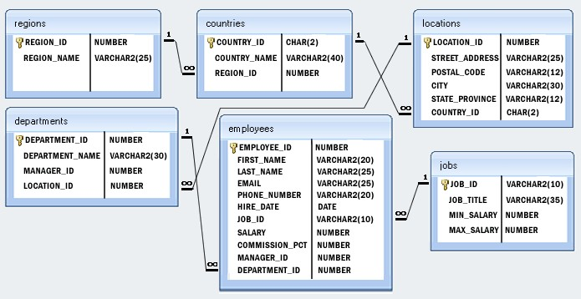Consider the following DB structure:

# Basic MySQL Part 1

## Subtopics:

* 1. Select, Distinct, as, WHERE,FROM,orderBy etc
  2. Conditions-And,oretc,Functions-count,sum,max

## Assignments CW :-

1. Write a query to display the names (first_name, last_name) using alias name “First Name", "Last Name"
2. Write a query to get unique department ID from employee table.
3. Write a query to get the total salaries payable to employees.
4. Write a query to get all employee details from the employee table order by first name, descending.
5. Write a query to get the names (first_name, last_name), salary, PF of all the employees (PF is calculated as 12% of salary).
6. Write a query to get the employee ID, names (first_name, last_name), salary in ascending order of salary.
7. Write a query to get the maximum and minimum salary from employees table.

## Assignments HW:-

1. Write a query to calculate 171*214+625
2. Write a query to get the average salary and number of employees in the employees table
3. Write a query to get the number of employees working with the company
4. Write a query to get the number of jobs available in the employees table
5. Write a query get all first name from employees table in upper case
6. Write a query to get the first 3 characters of first name from employee stable
7. Write a query to get the names (for example Ellen Abel, SundarAnde etc.) of all the employees from employees table
8. Write a query to get first name from employees table after removing white spaces from both side

## Assignments Additional

1. Write a query to get the length of the employee names (first_name, last_name) from employees table
2. Write a query to check if the first_name fields of the employees table contains numbers.
3. Write a query to select first 10 records from a table.
4. Write a query to get monthly salary (round 2 decimal places) of each and every employee. Note: Assume the salary field provides the 'annual salary' information.